**Scenario #1**

**Scenario Description**

* When a player loses double their bet when they lose. When a player doesn’t get a match, their balance goes down by twice the amount they bet.
* For example, if the player bets $5 on Prawn and the dealer rolls 2 Fish and 1 Stag then the player loses $10. The player is only mean to loses their bet of $5.

**Hypothesis of problem**

From the results found in the replication and simplification of scenario problem 1, the result of the user’s balance dropping by double the bet instead of just their bet is caused from either the bet being subtracted twice for no reason in a loop or the bet being double somewhere else in the punter or interactiveGame class.

**Location of the problem**

The location of the problem found was in the punter class, as interactiveGame class calls punter when a bet is first placed it removes the bet amount from the balance. Once that it returns the balance amount and continues the program, after the interactiveGame decides that the user loses it requests punter.loseBet() which removes the bet amount again and returns the amount making the lose double what it is meant to be. 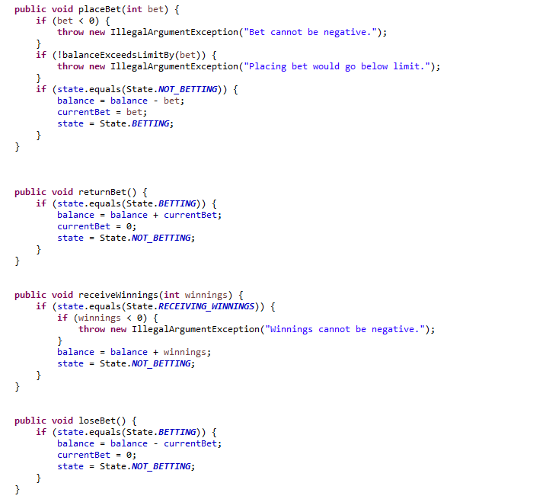

**Solution/Resolution**

To solve this problem in the program of removing bet twice from the balance of the user, the location of the problem was found where placeBet() was called and removed the bet before the game decided if it was a los and then after a lose, loseBet() was called after a lose and removed the bet again making it double. For a solution to fix the problem either placeBet() or loseBet() should be changed so that only one of them remove the bet amount. I would change loseBet() to only get balance and display it instead of also removing the bet, this would fix the problem as it would only remove the bet once in placeBet().